# Step by Step outline of the basic flow

­­­The flow of the data begins with two files, ‘StudentList.csv’ & ‘CourseList.csv’. These lists contain all of the necessary information about each of the courses and each individual student. For the student list, it will include details such as their unique student ID along with what course they are currently attending and which year group they are in. The course list file will contain information about each course, including details about the course such as academic staff involved with the subject and the number of students within that course. Both of these files get processed into the ‘Manage students’ use case, which processes the information such as adding, deleting or expanding upon it.

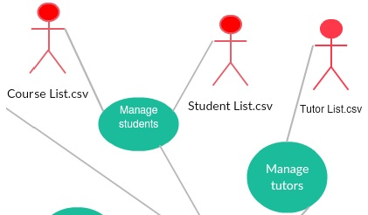Alongside the previous two lists is the ‘TutorList.csv’ which is a file containing all the necessary information about each tutor, such as whether they are part-time, full-time, PhD students and so on. This list gets processed through the ‘Manage tutors’ use case, which allows the admin to add, delete or modify the contents of the tutor list. This then links to the same actor as the ‘Manage students’ use case.

The previous two use-cases move forward to the actor ‘Admin’. The admin actor is responsible for managing all of the tutors and students as well as assigning them to their own individual groups. This is shown by the flow of data from the admin actor to the use-case ‘Manage tutor group’.

This shows the admin has full access to modify and manage the tutor groups which includes one tutor and several students (tutees). The other direction in which data flows from the admin is to the ‘View tutor groups’ use-case, showing that the admin modifies the tutor groups and then these tutor groups are viewed by the tutors and students alike.

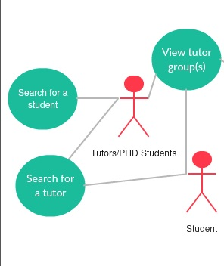

From here, the student actor and tutor actor can both view the tutor groups, which can only be modified by the admin. Both the student and tutor actor can gain access to the ‘Search for a tutor’ use-case, as it is a necessary function for both actors. The tutor actor also has exclusive access to the ‘Search for a student’ use-case, which allows them to find any student by name or ID. The same can be done in the ‘Search for a tutor’ use-case which allows any actors linked to search for a tutor by name.